School Games Commonwealth Inspired Festival
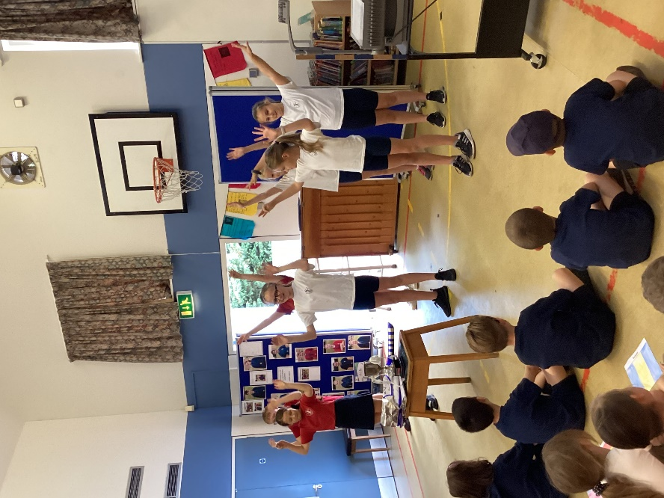
On Thursday 21st July, the entire school community joined together for a festival of sports centred around the forthcoming Commonwealth Games and its themes.
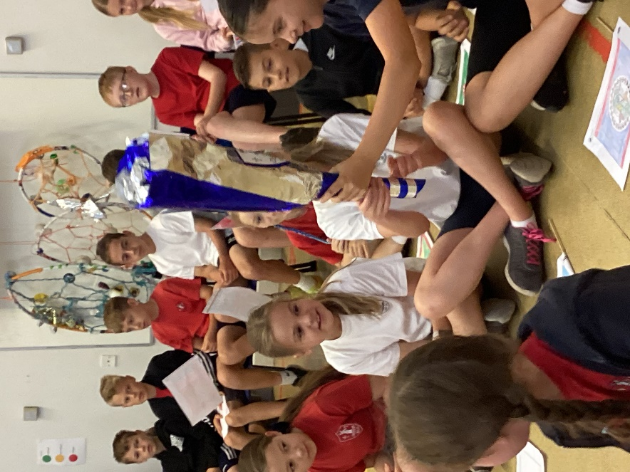
We began in the hall with a special assembly. Performance Club opened the festivities with their Mexican dance followed by the whole school singing our anthem for the event, ‘Today, Tomorrow and Forever,’ written by Mr Lawrence.
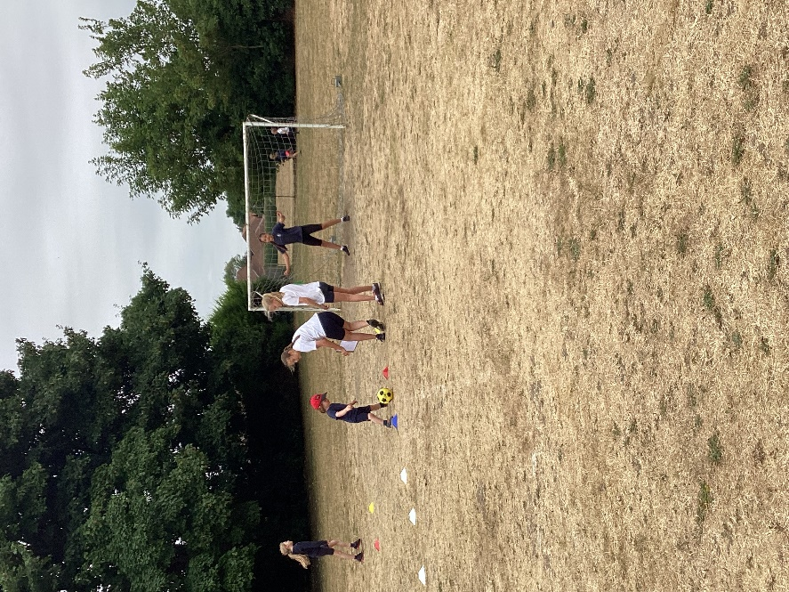
There then followed a carousel of activities based on sports which were expertly organised, run and scored by Class 4 as Young Leaders. These activities were: Boccia, Tri-golf dominoes, tennis, non-stop cricket, Golden Mile and football.
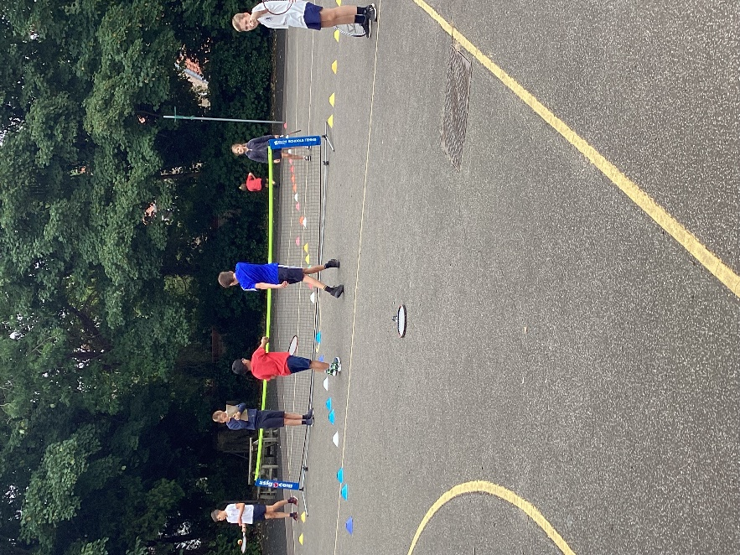
We were delighted to invite Mayor Councillor Charlie Pyatt and Mayoress Julie Pyatt for the end of event assembly. The mayor presented certificates to our Young Leaders and the trophy to the team which had scored the most points. Congratulations to Group 6!
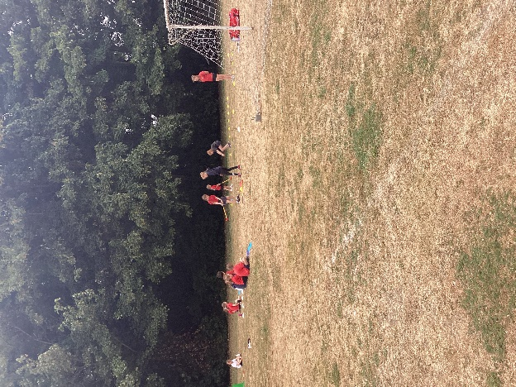
It was a very successful morning and we are very grateful to all of the staff and children who supported the festival.


