Area Sports 2022
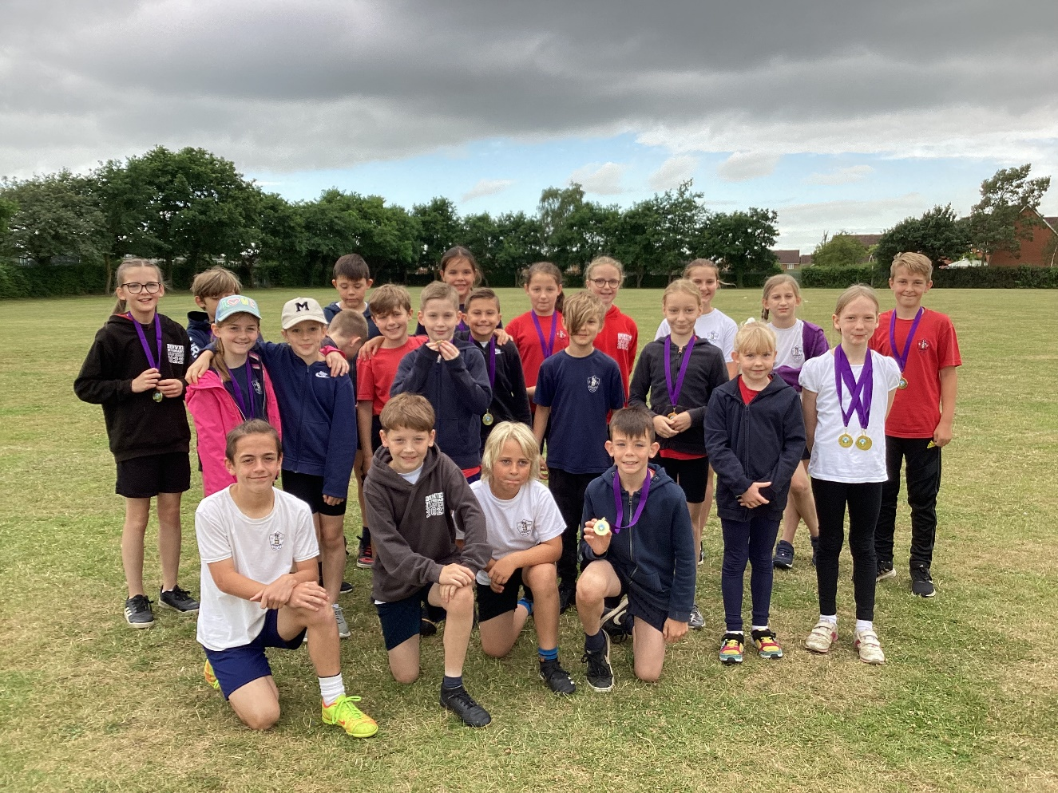
After a three-year break due to Covid, the Downham Market Cluster Area Sports event for Key Stage 2 finally resumed.
In past years, schools competed as a team in the small schools and large schools events. This year there were 8 teams in attendance so it was decided that the children would compete individually for medals in their respective events rather than as a schools competition. Medals were awarded for first place only.
The following events were held for Years 3, 4, 5 and 6: hurdles, endurance, sprint and a mixed team relay on the track; long-jump and vortex howler throw on the field. There was also a tennis ball throw for Years 3 and 4.
The children all represented the school very well and there were also many individual successes which s especially impressive when up against some much larger schools from the area.
Here are the medallists:
Year 3
Rosie – sprint
Rosie – long jump
Rosie- hurdles
Oliver – vortex howler
Jack – Long jump

Year 4
William – hurdles
Emie – endurance

Year 5
Chloe – hurdles
Joshua-Jon – hurdles
Brooke – long jump
Saffron – vortex howler

Year 6
Harry – hurdles
Kaylee – vortex howler.

It was a pleasure to take such an enthusiastic and sporting team. Well done to everyone!


